Summer training - 1st Test

1)Write a program to display the array element.

Answer:

#include <iostream>

using namespace std;

int main() {

// Declare and initialize an array

int arr[] = {10, 20, 30, 40, 50};

// Get the size of the array

int size = sizeof(arr) / sizeof(arr[0]);

// Display the array elements

cout << "Array elements are: ";

for (int i = 0; i < size; i++) {

cout << arr[i] << " ";

}

cout << endl;

return 0;

}

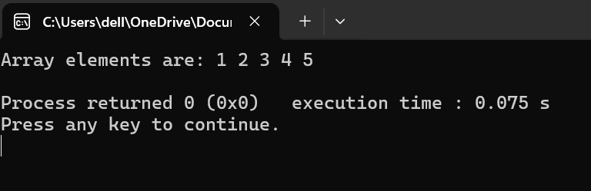

2)write a program to find the max element from the list.

Answer:

#include <iostream>

#include <list>

#include <limits>

using namespace std;

int main() {

// Create a list of integers

list<int> numbers;

int num, count;

// Input the number of elements

cout << "Enter the number of elements: ";

cin >> count;

// Input the elements

cout << "Enter the elements:\n";

for (int i = 0; i < count; i++) {

cin >> num;

numbers.push_back(num);

}

// Check if the list is empty

if (numbers.empty()) {

cout << "The list is empty." << endl;

return 0;

}

// Find the maximum element

int max_element = numeric_limits<int>::min();

for (int num : numbers) {

if (num > max_element) {

max_element = num;

}

}

// Display the original list

cout << "The list contains: ";

for (int num : numbers) {

cout << num << " ";

}

cout << endl;

// Display the maximum element

cout << "The maximum element is: " << max_element << endl;

return 0;

}

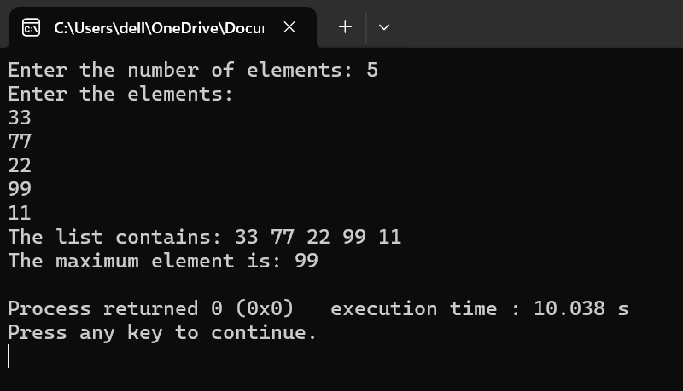

4)<https://leetcode.com/problems/two-sum/description/>

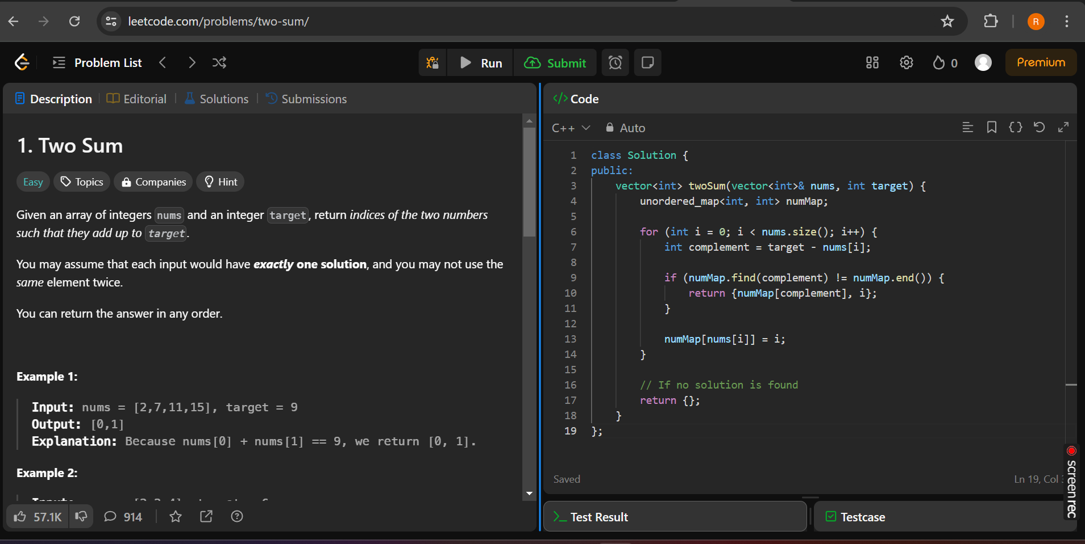

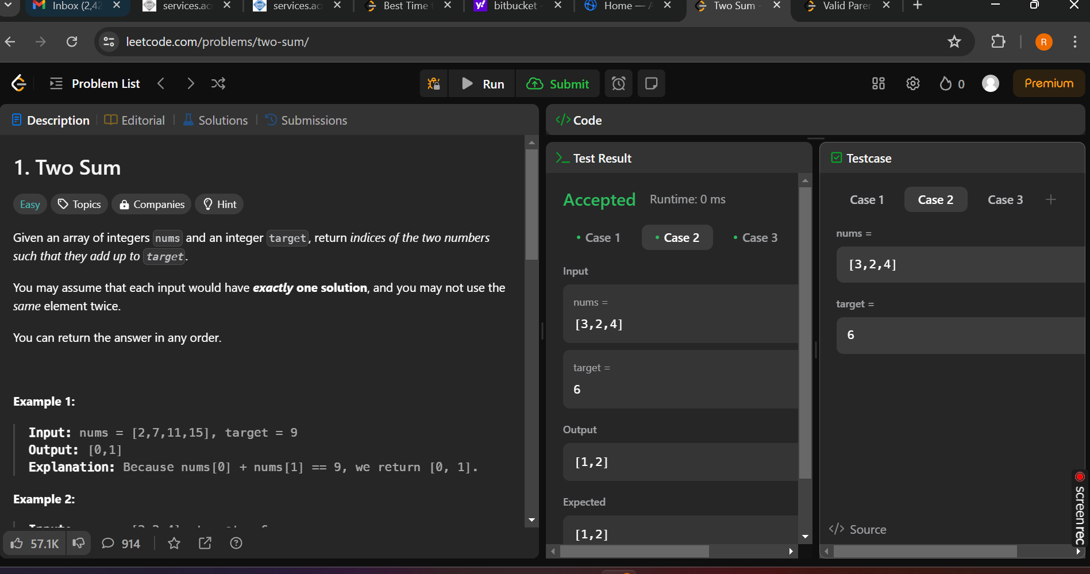

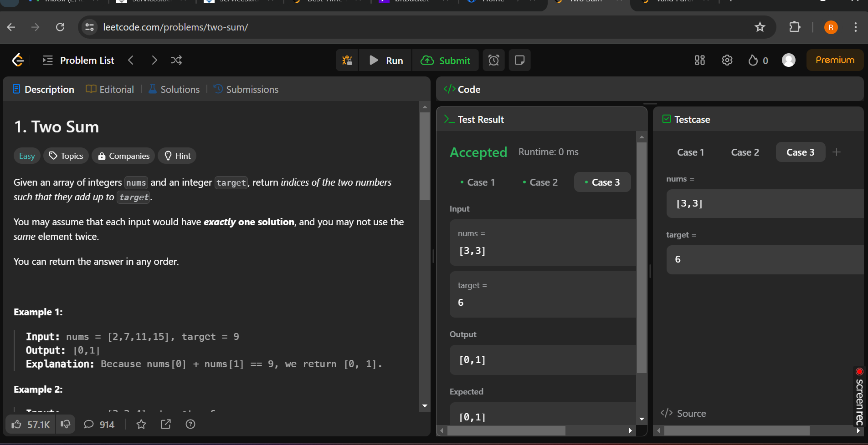

5)<https://leetcode.com/problems/valid-parentheses/>

Answer:

